St. Theresa’s Parish Community Newsletter

Administrator: Fr Dixon George IVDei
Presbytery: 17 Drummartin St., Albion 3020
Phone: 9311 3091
email: albion@cam.org.au
Website: https://pol.org.au/albion/Home.aspx
Polish Chaplain: Fr Marian Szeptak
Residence: 185 William St., St Albans 3021
Phone: 9310 9057

St. Theresa’s Primary School - 93119070
16 Drummartin St., Albion 3020
Principal: Rob Macklin

Mother of God Primary School - 93631734
Blanche St., Ardeer 3022
Principal: Assunta Iacovino

“Do Small Things Well”
_________________________________________

FIFTH SUNDAY OF EASTER Year B 27 & 28 April 2024

CATHOLICCARE VICTORIA SUNDAY APPEAL 4/5 May
As the Catholic Church’s mission in action, CatholicCare Victoria delivers programs and services to support families, children, young people and individuals to help everyone reach their full potential. The services include counselling and mental health services, specialised support for children and teens, refugee and asylum seeker help, pastoral care, support for separating families, social housing and homelessness support. Please donate to the CatholicCare Victoria Sunday Appeal. Your support and generosity will help provide caring and compassionate support for struggling individuals and families in our community. You can donate using the appeal envelope available in our parish, donate online at www.catholiccarevic.org.au or call (03) 9287 5513.

MASSES THIS WEEK  ST THERESA’S  Drummartin St, Albion  8.30am Friday Reconciliation  9am Friday  10.30am Sunday  MOTHER OF GOD  Blanche St, Ardeer  10am Wednesday (Pol)  9am Thursday  6pm Friday (Polish)  5pm Saturday Reconciliation  5.30pm Saturday  10.15am Sunday (Polish)  QUEEN OF HEAVEN  Holt St, Ardeer  8am Wednesday  8.30am Sunday Reconciliation  9.00am Sunday  RECONCILIATION  (Individual Confession) other times by Appointment  HOLY ROSARY  Before Wednesday & Friday Masses |  | CUPPA AFTER MASS Join us next weekend, 4th & 5th May after each Mass for a cuppa and a chat. Why not take this opportunity to enjoy the company of your fellow parishioners, and get to know one another better? Please bring a plate to share.  PARISH MOVIE MORNING Monday 29th April.  CLEANERS REQUIRED  People are needed for a cleaning roster at Mother of God. If you are able to help, please contact the parish office 9311 3091.  COLLECTIONS RECEIVED  Thanksgiving $713 Loose Money $206 Presbytery $574  PROJECT COMPASSION THANK YOU  Thank you to all who have given so generously. Please return any boxes or envelopes as soon as possible.  COUNTERS 5th May  Team 1: D Catania, E Catania, C Xuereb  FEAST DAYS  St Catherine of Siena, 29 April  READINGS Today Next Week  Acts 9.26-31 Acts 10.25-26,34-35,44-48  Psalm 22 Psalm 98  25b-26, 27+29, 30-31 (R.25a) 1, 2-3ab, 3cd-4 (R.2b)  1 John3.18-24 1 John 4.7-10  John 15.1-8 John 15.9-17

INFORMATION SESSION FOR THE PERMANENT DIACONATE
Open to single and married men, aged between 30 and 60 years of age. An information session will be held on Saturday 4th May, 10 – 11.45am at the Catholic Theological College, 278 Victorian Pde, East Melbourne. Ph: 9412 3357

REFLECTION by Fr Michael Tate

Spiritual Drink

We are too familiar with today’s gospel. Christ is the vine and we are the branches, sometimes in need of a good pruning. But God’s purpose is not to produce a perfect vineyard. It is to produce a full-bodied wine at the end of history.

There is a foretaste of this at every Mass. The wine we offer – ‘fruit of the earth and work of human hands’ – becomes the spiritual drink which best serves the purpose of our Heavenly Father. How does this happen?

For the Jewish people observing an animal whose throat is cut, it is obvious that the life drains out with the blood. ‘Life’ and ‘blood’ became synonyms. So, when the Jewish Jesus says of the wine in the chalice at the Last Supper: ‘This is my blood’, amongst other things he is saying: ‘This is my life force, this is my very life given unreservedly for you.’
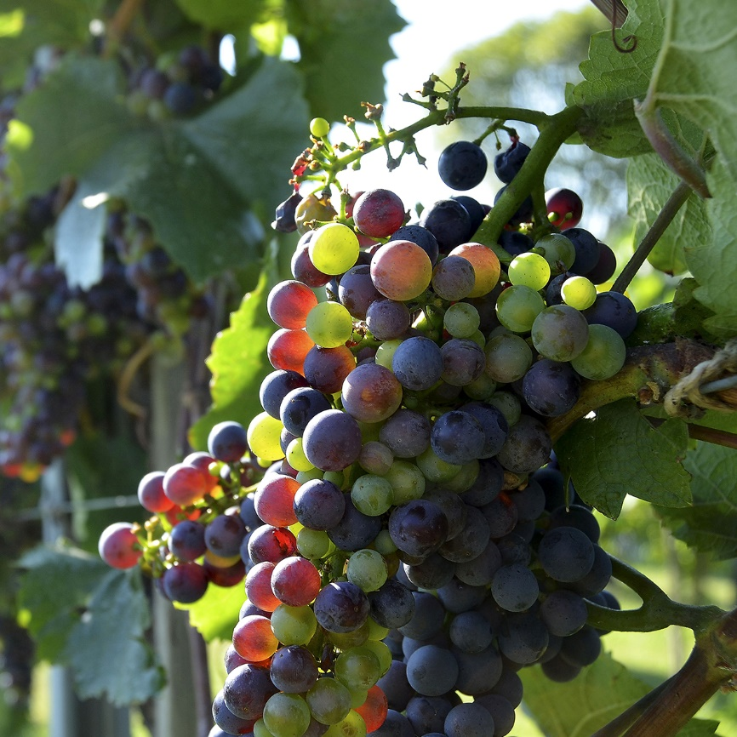

So, when we drink from the chalice at Holy Communion, the life of the Risen Lord courses through our bodies just as the sap of the vine courses through its branches. We share the same ultimate vitality so that our bodily existence builds into the Body of Christ. He becomes truly ‘full-bodied’ as the Divine Vigneron desires.

We could take a moment to pray that we respond to the pruning and the tending and the pressing by our Heavenly Father so as to contribute our distinctive character to the vintage at the end of history, the spiritual drink of the Kingdom of Heaven.

St Theresa’s Parish is committed to the safety of children, young people and vulnerable adults

